LAB 2
Title: To design and implementation of Deterministic Finite Automata (DFA) for various language.

Theory:
A Deterministic Finite Automaton (DFA) is a mathematical model of computation. It is a simple machine that reads a string of input symbols and decides whether to accept or reject the string. The term "deterministic" means that for each input symbol, there is exactly one state to which the machine can transition from its current state. DFAs are used to recognize regular languages.

Components of a DFA:
A DFA is formally defined as a 5-tuple: (Q,Σ,δ,q0,F), where:
- Q is a finite set of states. These represent the machine's configuration at any given time.
- Σ (Sigma) is a finite set of input symbols called the alphabet. This is the set of all possible characters the machine can read.
- δ (Delta) is the transition function. It's a mapping from a state and an input symbol to a single next state, denoted as δ(q,a)=q′, where q and q′ are states and a is an input symbol.
- q0 is the start state, an element of Q. This is where the machine begins processing the input string.
- F is a set of final (or accepting) states, a subset of Q. If the machine finishes reading the entire string and lands in a state from this set, the string is accepted.

Program 1: Design and Implementation of a DFA to accept strings over {0, 1} that ends with 11.
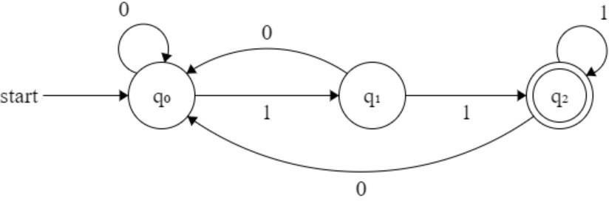
Source code:

#include <stdio.h>
#include <string.h>
int main()
{
char str[100];
int state = 0;
int i;
printf("Program by: Mahesh Udas \n");
printf("Enter a binary string: ");
scanf("%s", str);
for (i = 0; i < strlen(str); i++)
{
if (str[i] == '0')
{
if (state == 1)
state = 0;
else if (state == 2)
state = 1;
else
state = 0;
}
else if (str[i] == '1')
{
if (state == 0)
state = 1;
else if (state == 1)
state = 2;
else if (state == 2)
state = 2;
}
else
{
printf("Invalid input! Only 0s and 1s are allowed.\n");
return 0;
}
}
if (state == 2)
printf("String Accepted: Ends with 11\n");
else
printf("String Rejected: Does not end with 11\n");
return 0;
}

Output and Discussion:

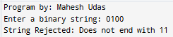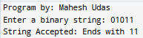

This C program simulates a finite state machine that checks whether a binary string ends with "11". It transitions through states based on input characters and validates binary format. If the final state equals 2, the string is accepted. Otherwise, it is rejected. It demonstrates basic automata logic and input validation effectively.

Program 2: Design and Implementation of a DFA to accept strings over {0, 1} that start with 01.
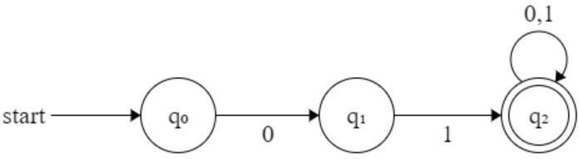
Source code:

#include <stdio.h>
#include <string.h>
int dfa_start_with_01(char str[])
{
int state = 0;
for (int i = 0; str[i] != '\0'; i++)
{
char ch = str[i];
switch (state)
{
case 0:
if (ch == '0')
state = 1;
else
state = 3;
break;
case 1:
if (ch == '1')
state = 2;
else
state = 3;
break;
case 2:
state = 2;
break;
case 3:
state = 3;
break;
}
}
return (state == 2);
}
int main()
{
char str[100]; printf("Program by: Mahesh Udas\n");
printf("Enter a binary string: "); scanf("%s", str);
if (dfa_start_with_01(str))
printf("ACCEPTED: The string starts with 01\n"); else
printf("REJECTED: The string does not start with 01\n");
return 0;
}

Output and discussion
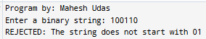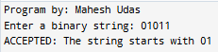

This C program uses a deterministic finite automaton (DFA) to check if a binary string starts with "01". It transitions through states based on character input and ends in an accepting state if the condition is met. The dfa_start_with_01 function handles logic, while main manages input and output. It illustrates automata principles and string validation effectively.
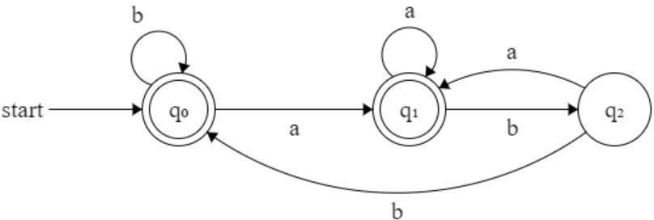
Program 3: Design and Implementation of a DFA to accept string over {a, b} such that string does not end with ab.
Source code

#include <stdio.h>
#include <string.h>
#define Q0 0
#define Q1 1
#define Q2 2
int dfa_accepts(const char *str)
{
int state = Q0;
int i;
for (i = 0; i < strlen(str); i++)
{
char ch = str[i];
switch (state)
{
case Q0:
if (ch == 'a')
state = Q1;
else if (ch == 'b')
state = Q0;
else
{
printf("Invalid character: %c\n", ch);
return 0;
}
break;
case Q1:
if (ch == 'a')
state = Q1;
else if (ch == 'b')
state = Q2;
else
{
printf("Invalid character: %c\n", ch);
return 0;
}
break;
case Q2:
if (ch == 'a')
state = Q1;
else if (ch == 'b')
state = Q0;
else
{
printf("Invalid character: %c\n", ch);
return 0;
}
break;
}
}
return (state == Q0 || state == Q1);
}

int main()
{
char str[100];
printf("Program by: Mahesh Udas\n");
printf("Enter a string over {a,b}: ");
scanf("%s", str);
if (dfa_accepts(str))
printf("String is Accepted\n");
else
printf("String is Rejected\n");
return 0
}

Output and discussion

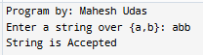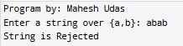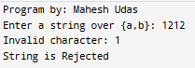

This C program implements a deterministic finite automaton (DFA) to evaluate strings over the alphabet
{a, b}. It transitions through states Q0, Q1, and Q2 based on input characters. Invalid characters are flagged immediately. The DFA accepts strings that end in either Q0 or Q1, rejecting those that terminate in Q2. The logic is encapsulated in dfa_accepts, while main handles input and output. This program demonstrates fundamental concepts of automata theory, including state transitions, input validation, and final state acceptance. It is a practical example for understanding how DFAs process strings and determine language membership based on defined rules.

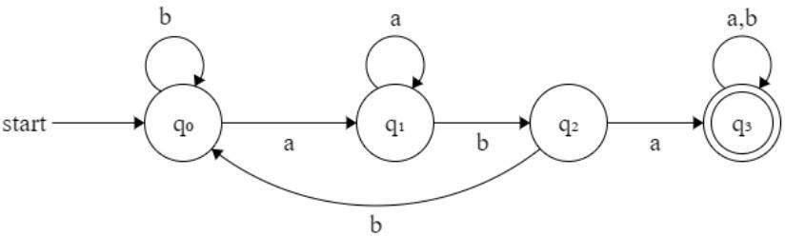
Program 4: Design and Implementation of a DFA to accept string over {a, b} such that each string contain aba as substring.
Source code

#include <stdio.h>
#include <string.h>
int main()
{
char str[100];
int state = 0;
printf("Program by: Mahesh Udas \n");
printf("Enter a string over {a, b}: ");
scanf("%s", str);
for (int i = 0; str[i] != '\0'; i++)
{
char ch = str[i];
switch (state)
{
case 0:
if (ch == 'a')
state = 1;
else if (ch == 'b')
state = 0;
else
{
printf("Invalid character detected.\n");
return 1;
}
break;
case 1:
if (ch == 'a')
state = 1;
else if (ch == 'b')
state = 2;
else
{
printf("Invalid character detected.\n");
return 1;
}
break;
case 2:
if (ch == 'a')
state = 3;
else if (ch == 'b')
state = 0;
else
{
printf("Invalid character detected.\n");
return 1;
}
break;
case 3:
if (ch == 'a' || ch == 'b')
state = 3;
else
{
printf("Invalid character detected.\n");
return 1;
}
break;
}
}

if (state == 3)
printf("String accepted! It contains 'aba'.\n");
else
printf("String rejected! It does not contain 'aba'.\n");
return 0;
}

Output and discussion

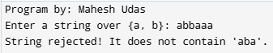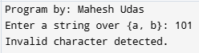

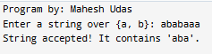

This C program checks if a string over {a, b} contains the substring "aba" using a finite state machine. It transitions through four states (0 to 3) based on input characters. Starting from state 0, it moves to state 1 on 'a', then to state 2 on 'b', and finally to state 3 on another 'a'. Once in state 3, it remains there regardless of further input. If the final state is 3, the string is accepted; otherwise, it is rejected. Invalid characters trigger an error. This approach efficiently detects the presence of "aba" in a given input string.

Conclusion:
This lab successfully demonstrated the design and implementation of Deterministic Finite Automata (DFA) for recognizing various regular languages over binary and alphabetic inputs. Four distinct DFA programs were developed: accepting strings ending with "11", starting with "01", not ending with "ab", and containing "aba" as a substring. Each implementation utilized state-based logic with switch-case structures to handle character transitions effectively. The programs highlighted fundamental automata theory concepts including state transitions, input validation, and acceptance conditions. Through practical coding exercises, we gained hands-on experience in translating theoretical DFA designs into functional C programs, reinforcing understanding of finite state machines, regular language recognition, and computational models essential for compiler design and formal language processing.

